**Video Hadoop Introduction**

Time spent: 30min

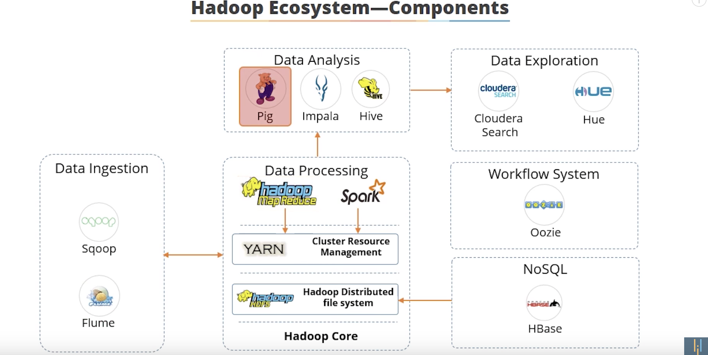

**Hadoop Architecture**

Hadoop framework includes following four modules:

* Hadoop Common: These are Java libraries and utilities required by other Hadoop modules. These libraries provide filesystem and OS level abstractions and contains the necessary Java files and scripts required to start Hadoop.
* Hadoop YARN: This is a framework for job scheduling and cluster resource management.
* Hadoop Distributed File System (HDFS™): A distributed file system that provides high-throughput access to application data.
* Hadoop MapReduce: This is YARN-based system for parallel processing of large data sets.

**MapReduce**

Hadoop MapReduce is a software framework for easily writing applications which process big amounts of data in-parallel on large clusters (thousands of nodes) of commodity hardware in a reliable, fault-tolerant manner.

The term MapReduce actually refers to the following two different tasks that Hadoop programs perform:

* The Map Task: This is the first task, which takes input data and converts it into a set of data, where individual elements are broken down into tuples (key/value pairs).
* The Reduce Task: This task takes the output from a map task as input and combines those data tuples into a smaller set of tuples. The reduce task is always performed after the map task.

Typically both the input and the output are stored in a file-system. The framework takes care of scheduling tasks, monitoring them and re-executes the failed tasks.